Manila Water Company

technical specification - Enhancement

DID_M2C_202

UI for Creation of SR to perform permanent Disconnection
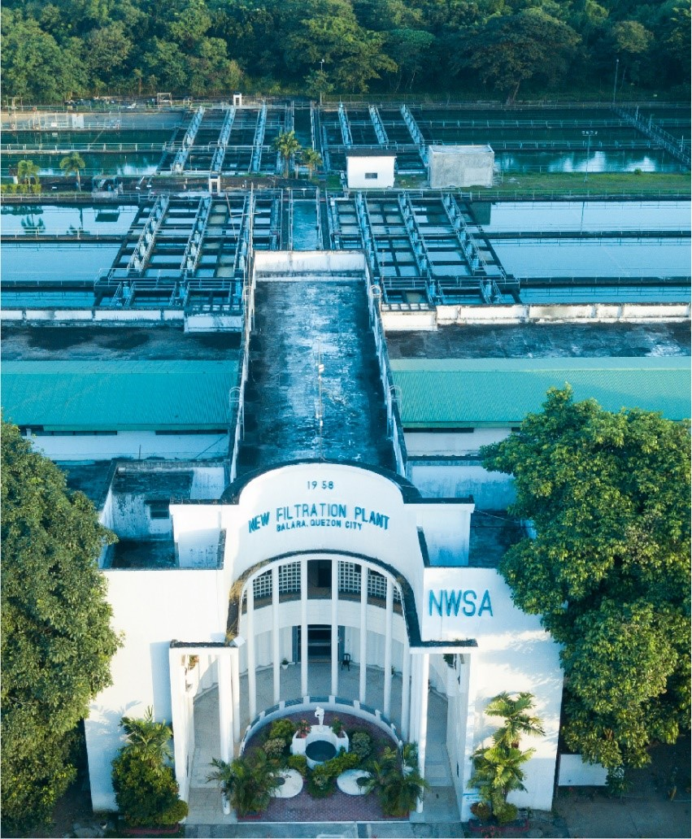
Contents
1 Document Organization 4
1.1 Document Log 4
1.2 Integration, Document Reference 4
2 Program Attributes 5
2.1 Authorization Requirements 6
2.1.1 Definition 6
2.1.2 Defined Fields 7
2.1.3 Procedure 7
2.2 Technical Flow Diagram 7
2.3 Processing Logic 7
2.4 Error handling 7
2.5 BRF Details 7
2.6 Fiori Extension 7
2.7 Cloud Extension 7
2.8 Custom DDIC Objects 8
2.9 Custom Business Object Details 8
2.10 Custom CDS Views Details 8
2.11 Custom Field details 8
2.12 Custom Logic/Enhancement Details 9
2.13 Custom Reusable Elements (Code-list, Library) 9
2.14 Form & Email Extensibility 9
2.15 Messages 10
2.16 Subroutines 10
3 Assumptions in Technical Design 10
4 Open Issues in Technical Design 10
5 Unit Test Results 10
6 Related Documentation 11

Document Organization
This section provides details about this document, previous version(s) of this document and the document(s) referred.

Document Log
Following table mentions the version changes and the processer(s):
Version | Status | Date | Version Created by (Name/E-Mail/Company) | Role | Comments
1.0 | Draft | July 29, 2025 | Sayyad Sarfraz Ali(sayyad.sarfraz@diligentglobal.com) | Author | Initial Draft

Integration, Document Reference

S. No. | Referred Document Name | Referred Document Version | Referred Document URL (Optional)
1 | MWC_DID_M2C_202-UI for Creation of SR to perform permanent DisconnectionReconnection | 1.0 | Attached below under Related Documentation

Program Attributes

Include | ZIN_M2C_SR_PERM_DISC_TOP.  ZIN_M2C_SR_PERM_DISC_C01.  ZIN_M2C_SR_PERM_DISC_E01.  ZIN_M2C_SR_PERM_DISC_F01.
Program | ZAB_M2C_SR_PERM_DISC
Transaction | ZTR_M2C_PERM_DISC
Table | ZDT_M2C_SR_LOG

Authorization Requirements
Authorization requirement where Business defined role for CORE team should have this transaction. This t-code should not be allowed to be executed by any other.

Definition
NA

Defined Fields
NA

Procedure
This report is used to create Service Requests (SRs) for customers. It starts by showing a selection screen where the user can enter filters like document number, contract account, business partner installation number, and device serial number, etc. The system checks the inputs first. If no matching data is found, an error message is shown and the program stops.
If the inputs are valid, the program reads data from a custom database view (ZI_M2C_SR_PERM_DISC) based on the user’s filters. For each record it finds, it also calculates the customer’s balance using a standard function module. The data is then prepared and stored in an internal table which is used to show the output.
The output is displayed in an ALV grid. The user can select one or more rows from the report using checkboxes or by clicking on them.
There is a custom execute button in the report toolbar. When the user clicks it, the system checks which rows are selected. For each selected record, if an SR has not already been created, the system collects the necessary details and calls a custom class (ZCL_M2C_MASS_CREATE_SR -> MASS_SR_CREATION) to create the SRs. The result (either success or failure) is updated back into the report table, including the new SR number and a message along with it.
The system also saves a log of each SR creation in a custom table (ZDT_M2C_SR_LOG). Once the processing is done, the report automatically refreshes to show the updated SR numbers and messages for each row.

Technical Flow Diagram
Enter required fields
Click execute
ALV display based as results
Report (ZAB_M2C_SR_PERM_DISC) will get execute by tcode (ZTR_M2C_PERM_DISC)
Records selected for SR Creation
After processing logs are stored in table (ZDT_M2C_SR_LOG)
Refreshed ALV is displayed

Processing Logic
- Execute program ZAB_M2C_SR_PERM_DISC
- Input selection fields and press execute
- Output will we displayed as ALV
- Select records and press execute button
- SR is created for each selected records
- Log table ZDT_M2C_SR_LOG also updated
- ALV is refreshed and is displayed again

Error handling
- If data is not found based on the input parameters, “No data found for the selection”.

BRF Details
N/A

Fiori Extension
N/A

Cloud Extension
N/A

Custom DDIC Objects
Database Table : ZDT_M2C_SR_LOG
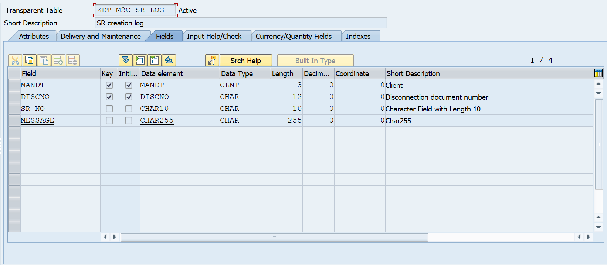

Custom Business Object Details
N/A

Custom CDS Views Details
- ZI_M2C_SR_PERM_DISC

Custom Field details

Custom Logic/Enhancement Details

Enhancement Name
Logic | NA

Custom Reusable Elements (Code-list, Library)

Custom Code list
Used in | NA

Custom Library Name

Form & Email Extensibility

Form Templates | NA
Email Templates | NA
Data Source Details | NA

Messages
Message Class | Message ID | Message Text
ZMC_M2C_FICA | 038 | Select at least one line.
ZMC_M2C_FICA | 039 | No data found for the selection

Subroutines
Name | Description
Get_data | Fetch data from cds view
Display alv | Display alv and provide on click functionality

Assumptions in Technical Design
NA

Open Issues in Technical Design
NA

Unit Test Results

Scenario # | Input Selection Criteria | Expected Result | Actual Test Pass/Fail
1 | Create Permanent Disconnection SR | Permanent Disconnection SR is created | Pass
2 | Create an SR for a record where and SR is already created | System will not crate new SR | Pass

Related Documentation

